Quick steps to run Gauntlet

- Choose Startup Project:
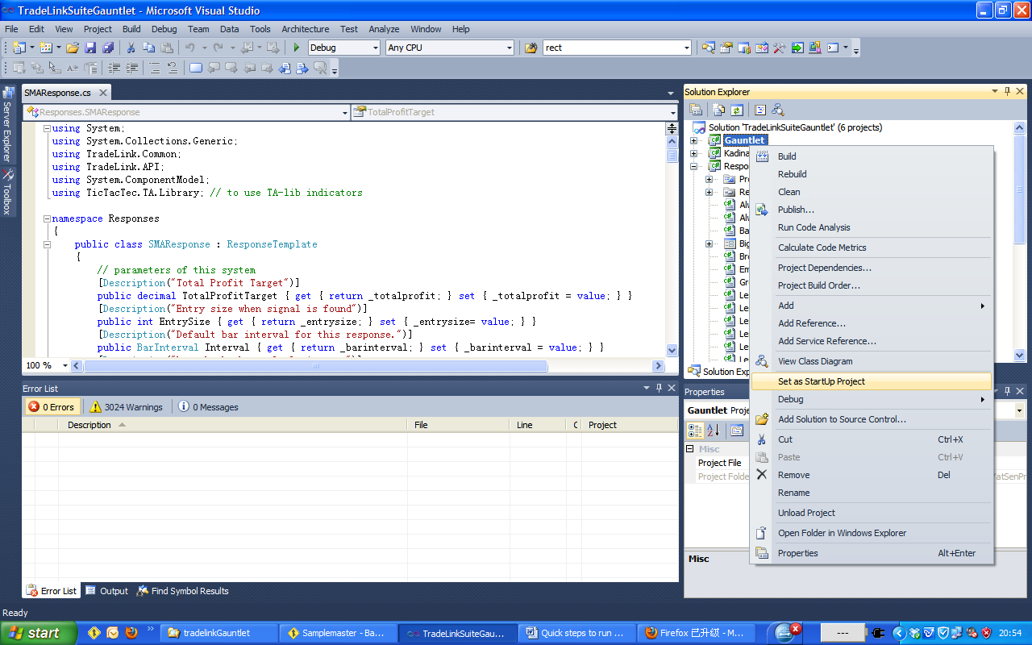
Choose Gauntlet as the startup project as shown.
Right click Gauntlet, select “Set as StartUp Project” in VS2010.
.
2) Build Project:

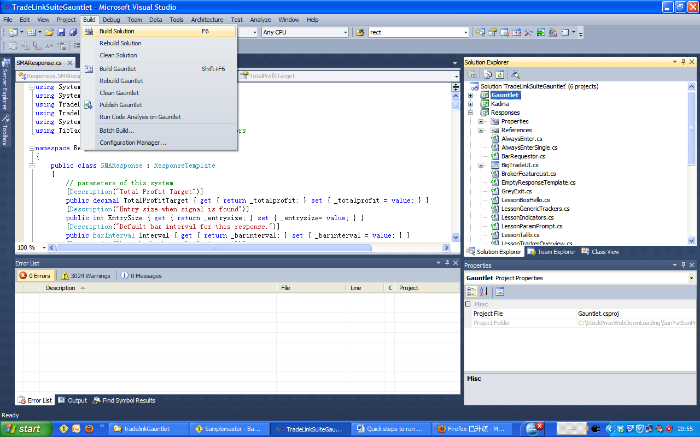
Make whatever changes you need to responses, then compile (build) Gauntlet as shown in the above picture.
Press F6 or select Build->Build Solution from VS2010.
3) Run Project:

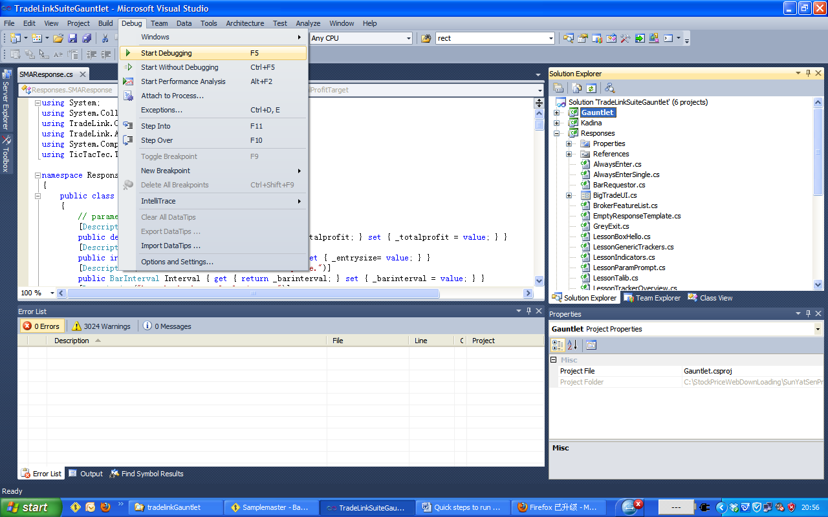
To run the project, press F5 or choose Debug->Start Debugging in VS2010.
Gauntlet will be shown as below.
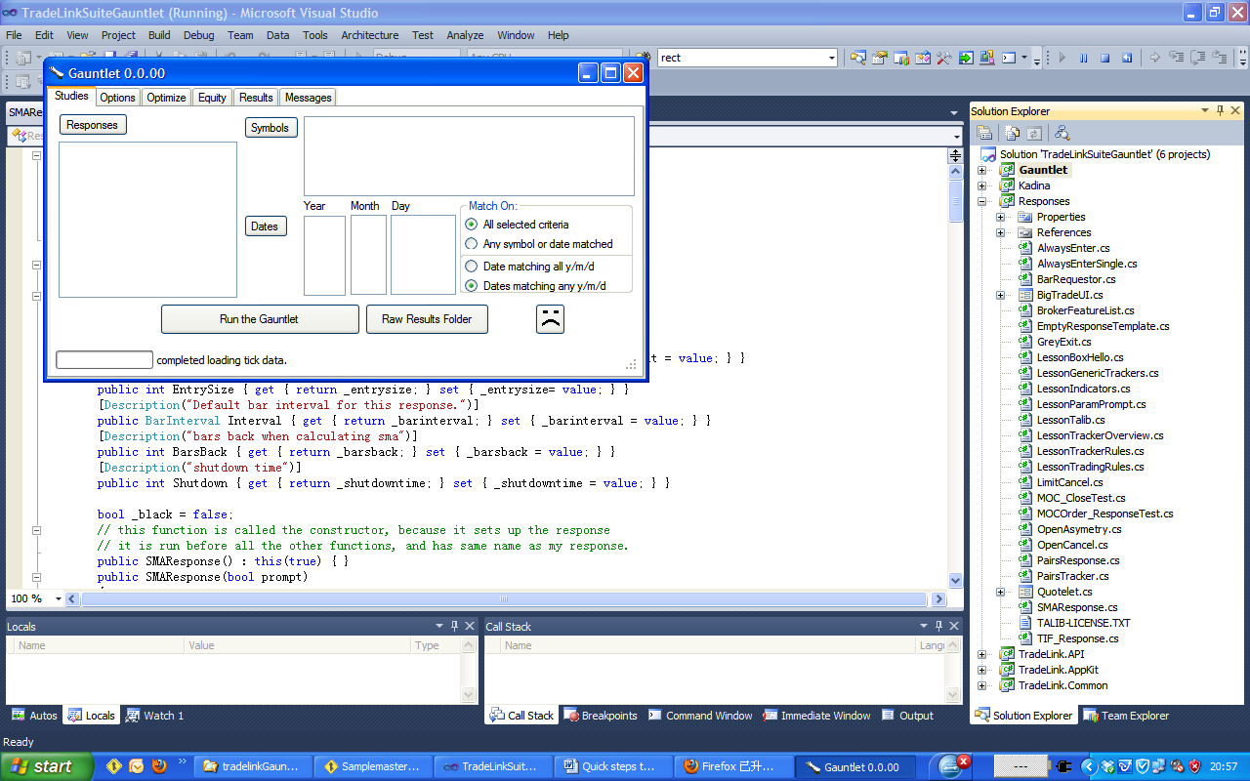
4) Choose tick data source:

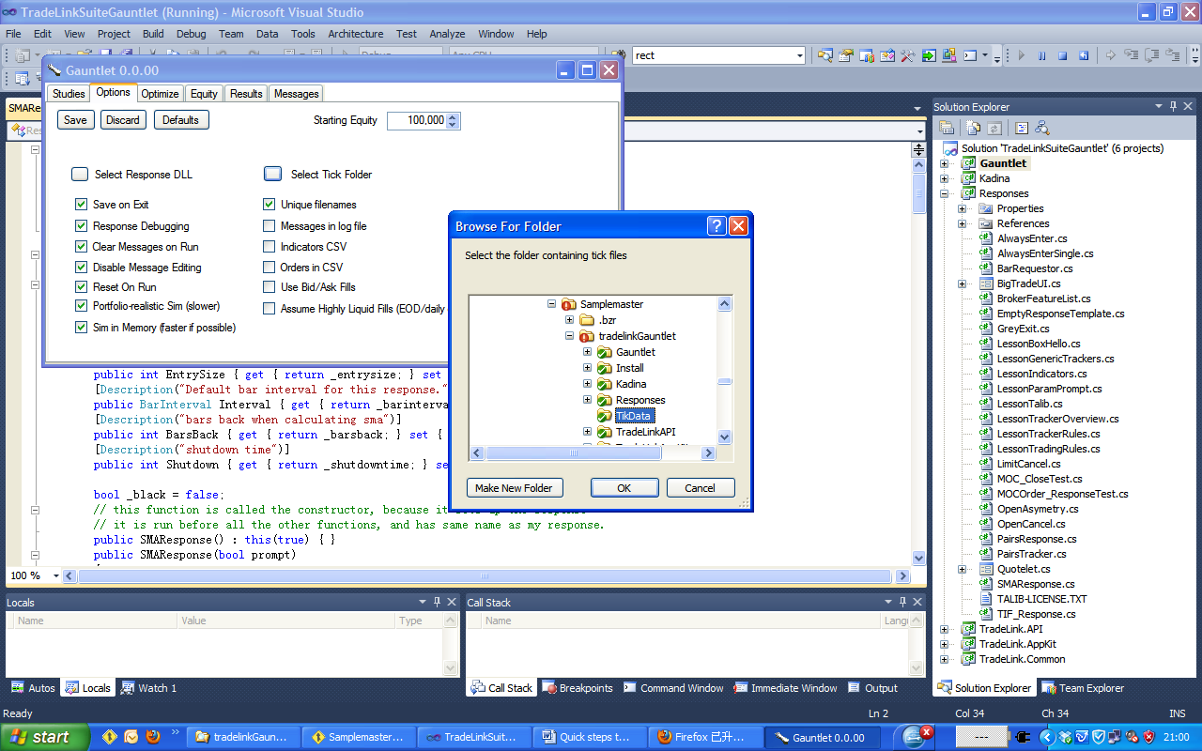
To choose the tick data used to run Gauntlet, select the “Options” tab and click the “Select tick folder” button, choose the folder that contains the tick data. With the projects I sent you, choose
tradelinkGauntlet\TikData

5) Load response DLL:

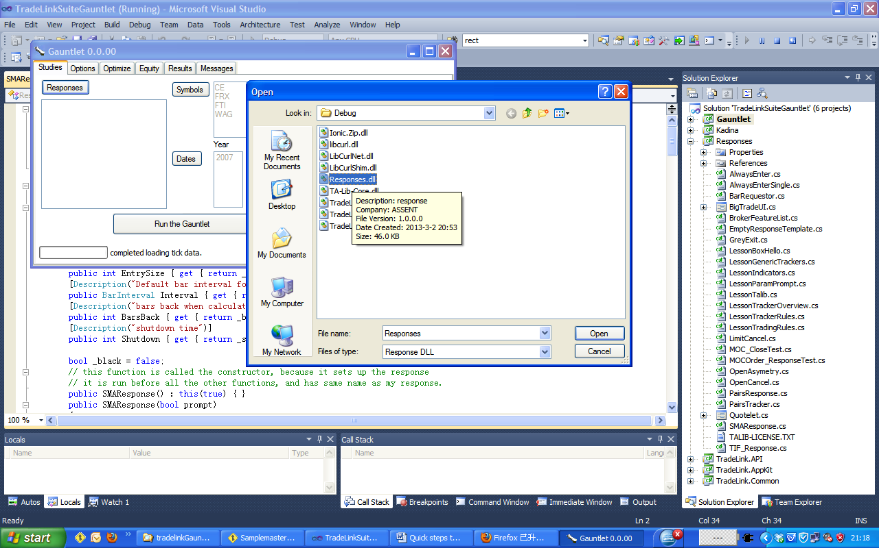
To run strategy, you need to choose the DLL that contains the responses (strategies) we built.
Select the “Studies” tab and click the “Responses” button, choose the proper folder that contains the needed DLL. With the projects I sent you, choose tradelinkGauntlet\Responses\bin\Debug\ Responses.dll.

6) To run Gauntlet,
a) Choose the “Studies” tab.
b) Click the “Symbols” button.
c) Choose one of the symbols (WAG for example)
d) Click the “Dates” button, choose a date
e) Choose a response from the box next to the “Response” button (Responses.HelloWorld for example)
f) Click the “Run the Gauntlet” button.
g) Choose the “Message” tab to see output result when f) is done.
